In this project, we have taken 40 nodes each node having same energy. Whenever the nodes transmit or receive data they lose energy. These 40 nodes are distributed randomly in the (100,100) area. Each quadrant has a cluster head chosen randomly. Here we have taken 4 CH in each quadrant and remaining as sensor nodes (SN).

Encoding

Each node is encoded into a string of length 9. In this chromosome, first 3 bits is energy, next 3 bits are distance from base station, last 3 bits are neighbour .

Fitness function calculation

Here we calculated fitness value for each node using the formula

Probability density function

Based on the fitness values of each node, we calculated the value of pdf to decide which node becomes next CH in next generation

Crossover operation

We perform the crossover of nodes by swapping at the middle.

LEACH

Elapsed time is 5.421409 seconds.

Elapsed time is 8.932985 seconds.

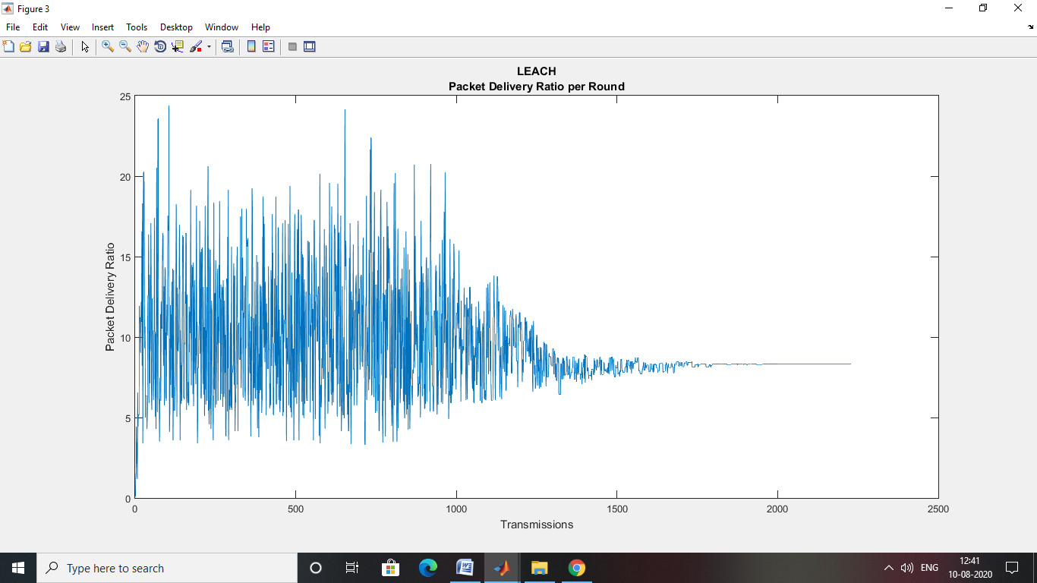

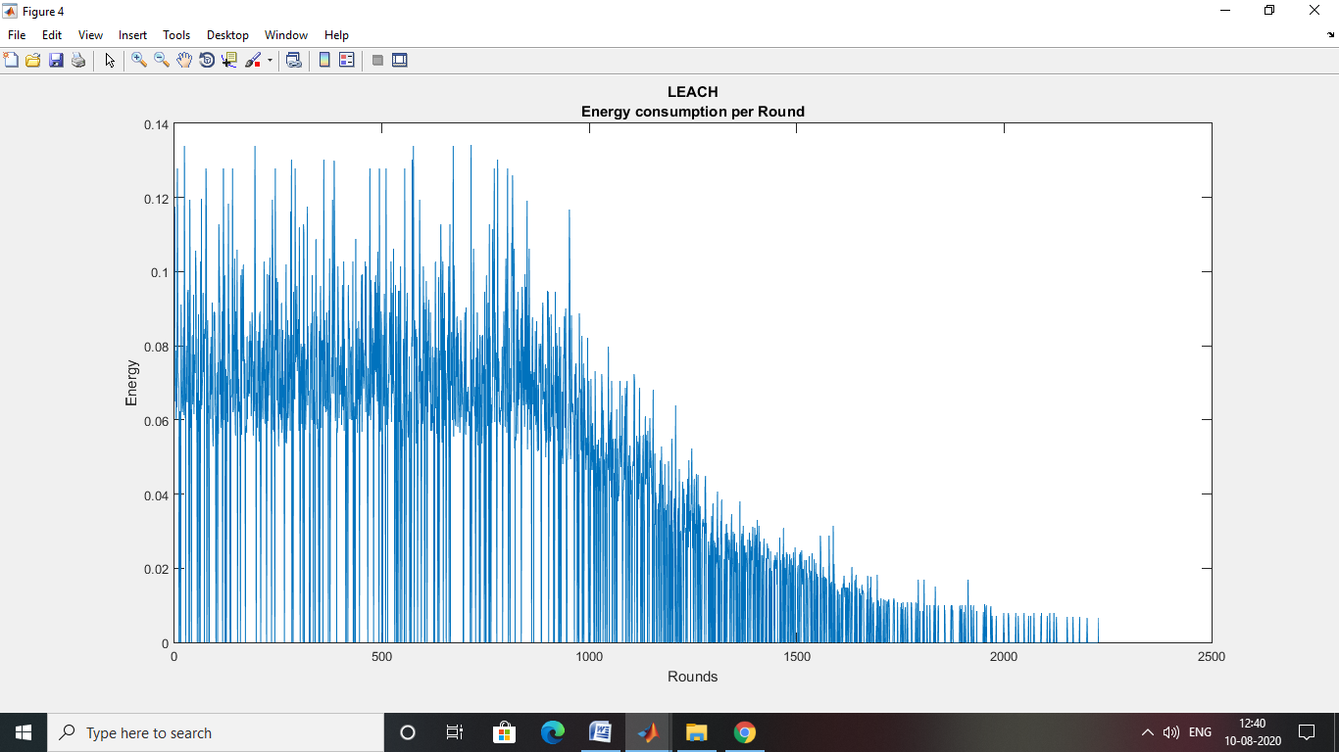

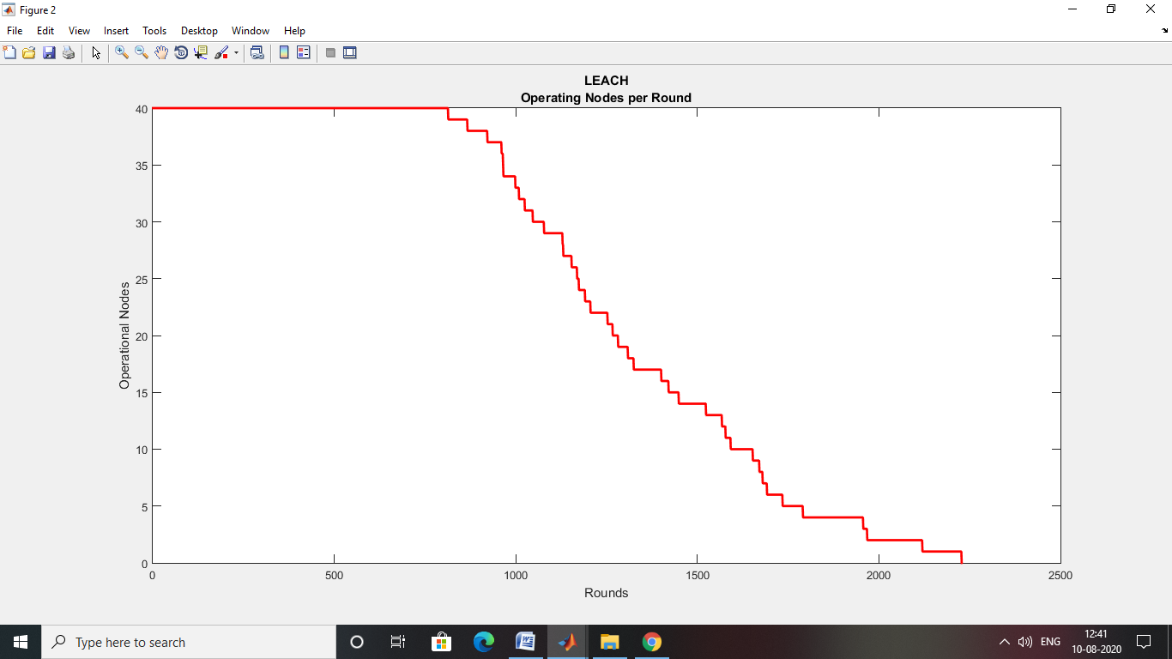

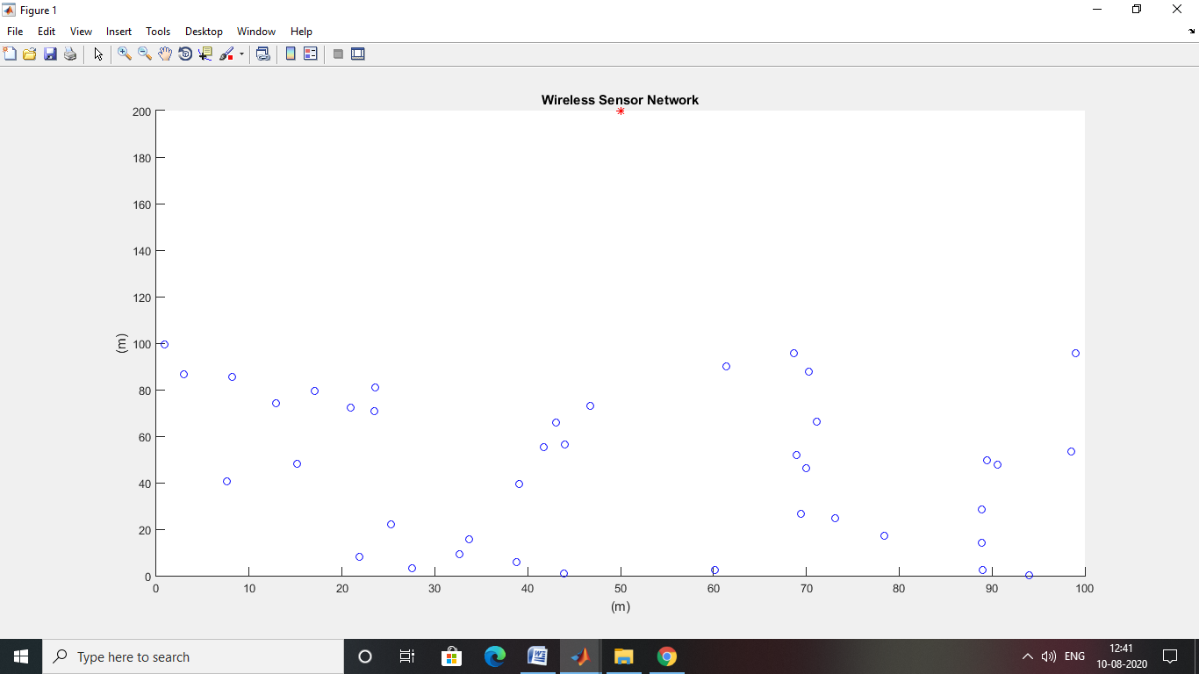

GA

Elapsed time is 50.690748 seconds.

Elapsed time is 52.606091 seconds.

